# **The Tableau HR Scorecard: Measuring Success in Talent Management**

INTRODUCTION :

Overview,

The Tableau HR Scorecard is a framework designed to measure and evaluate the success of talent management strategies within an organization. It provides a way for HR professionals and business leaders to track and analyze key performance indicators (KPIs) related to workforce planning, recruitment, retention, and development.

PROBLEM STATEMENT &DESIGN THINKING ,

1. **Optimizing HR Investments**: Organizations need to understand how their investments in HR activities, such as recruitment, training, and compensation, impact the overall financial health of the company. The financial perspective of the HR Scorecard helps in assessing whether these investments are cost-effective and contribute positively to the bottom line.
2. **Employee and Stakeholder Satisfaction**: Ensuring that employees, managers, and job candidates are satisfied with HR services is crucial for employee retention, engagement, and overall organizational performance. The customer perspective allows organizations to gauge their effectiveness in meeting the needs and expectations of these stakeholders.
3. **Operational Efficiency**: HR processes, such as recruitment, onboarding, and performance management, can be resource-intensive and time-consuming. The internal process perspective helps in identifying bottlenecks and areas where process improvements are needed to streamline HR operations.

EMPATHY MAP “

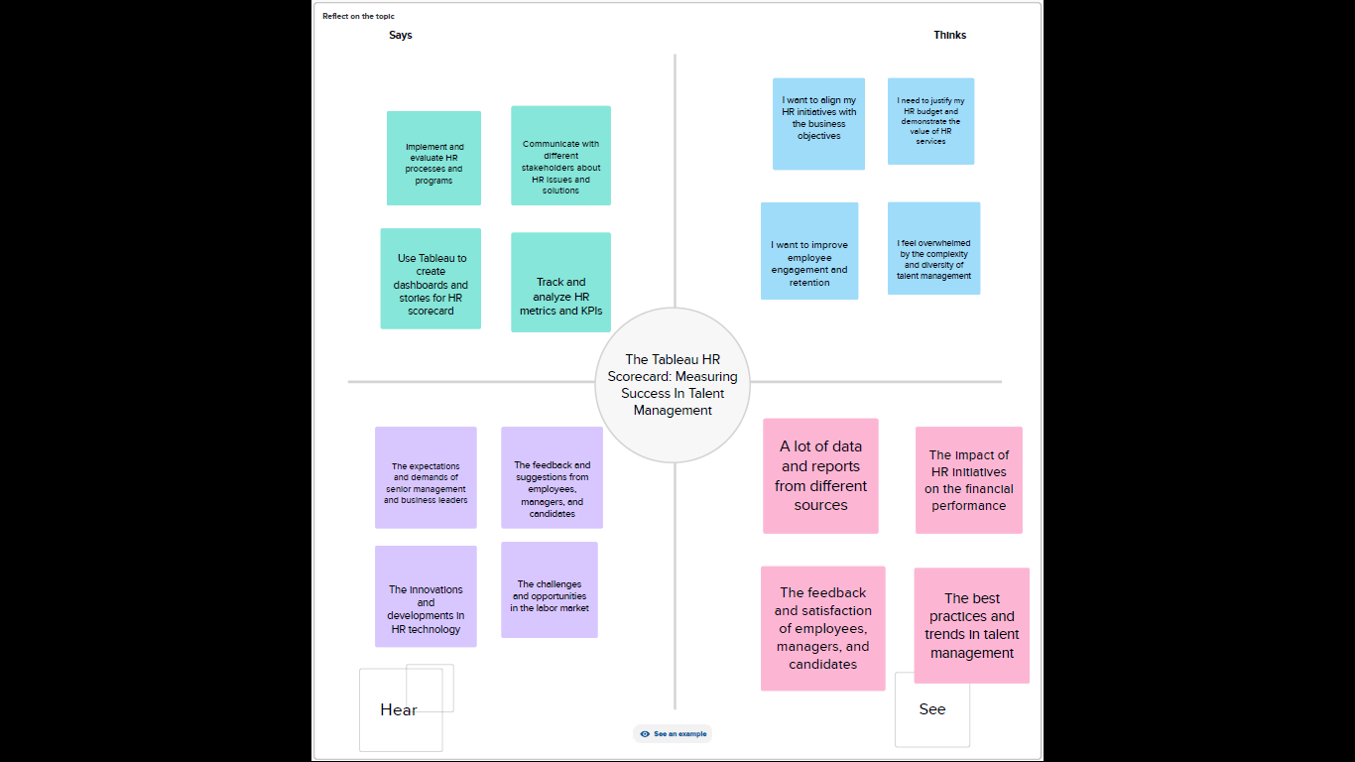

IDEATION & BRAINSTORMING MAP ‘

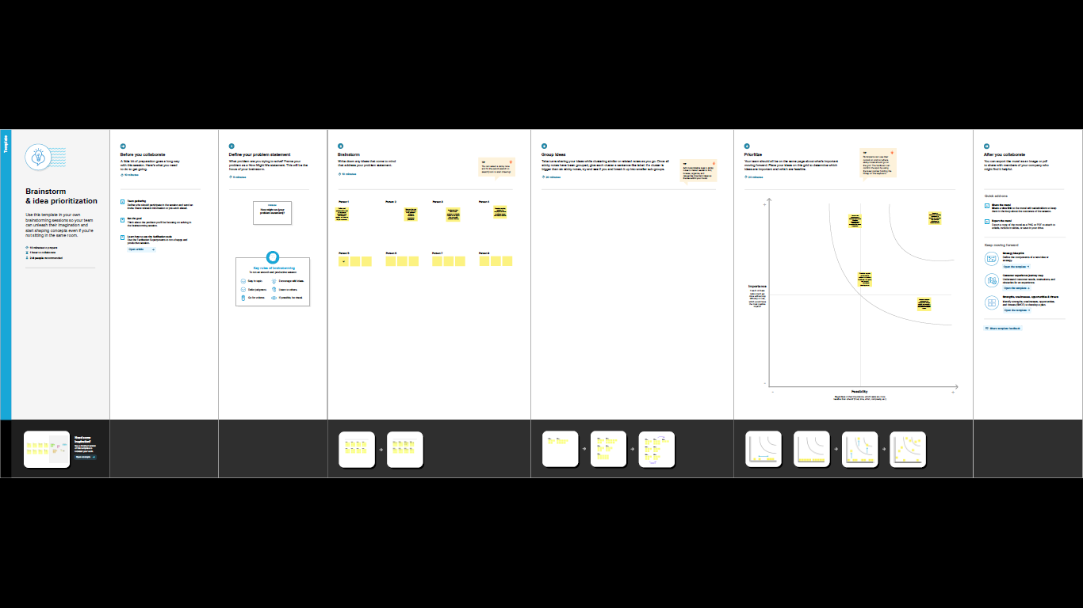

PURPOSE :

1. **Performance Measurement and Evaluation**: The project aims to establish a structured system for measuring and evaluating HR performance across various dimensions, providing a clear understanding of how HR initiatives impact the organization.
2. **Alignment with Business Goals**: The project seeks to align HR strategies and activities with the broader business objectives of the organization. By tracking key metrics, HR can ensure its efforts are in sync with the company's mission and vision.
3. **Data-Driven Decision-Making**: The Tableau HR Scorecard project intends to enable data-driven decision-making in HR. It provides a platform for HR professionals and business leaders to base their decisions on quantifiable metrics, improving the accuracy and effectiveness of HR strategies.

ADVANTAGES :

1. **Strategic Alignment**: The HR Scorecard allows organizations to align their HR practices with overall business strategy. By measuring HR performance against key business objectives, it ensures that HR initiatives support and contribute to the achievement of strategic goals. This alignment leads to a more focused and effective HR function.
2. **Data-Driven Decision-Making**: Implementing the HR Scorecard promotes data-driven decision-making in HR. It provides access to real-time and historical HR performance data, enabling HR professionals and business leaders to make informed decisions and adjustments to their talent management strategies based on concrete metrics rather than intuition or anecdotal evidence.
3. **Continuous Improvement**: The HR Scorecard facilitates a culture of continuous improvement within the HR department. By tracking key performance indicators and identifying areas that require attention or enhancement, HR can implement changes to optimize processes and practices continually. This leads to more efficient HR operations and better support for employees and the organization.

DISADVANTAGES :

1. **Resource Intensive**: Implementing and maintaining the HR Scorecard system can be resource-intensive. It requires not only the initial setup but also ongoing data collection, analysis, and reporting efforts. This can place a burden on HR teams and require investments in technology and training.
2. **Data Quality and Availability**: To effectively use the HR Scorecard, organizations need accurate and consistent data. Inaccurate or incomplete data can lead to incorrect conclusions and decisions. Ensuring data quality and availability can be a significant challenge, particularly in organizations with disparate HR systems and data sources.
3. **Overemphasis on Metrics**: There is a risk of overemphasizing metrics at the expense of the broader HR strategy and human-centric considerations. Relying solely on KPIs and metrics might lead to a narrow focus on quantifiable results, potentially neglecting important qualitative aspects of HR, such as employee morale, culture, and well-being.

Top of Form

APPLICATION :

1. **Performance Monitoring and Reporting**: The primary application of the HR Scorecard is to monitor and report on HR performance. It provides a visual and data-driven representation of key HR metrics, which can be regularly reviewed by HR professionals and organizational leaders. By using Tableau or similar data visualization tools, organizations can create dynamic dashboards and reports that offer insights into recruitment, employee development, satisfaction levels, and other critical HR indicators.
2. **Strategic Decision-Making**: The HR Scorecard serves as a valuable tool for strategic decision-making. HR leaders and senior management can use the insights from the scorecard to make informed decisions regarding HR strategies, resource allocation, and process improvements. For example, if the scorecard reveals a high turnover rate, HR can investigate the root causes and implement retention strategies.

CONCLUSION :

1. **Data-Driven Decision-Making**: The HR Scorecard promotes a data-driven approach to HR management. By providing a systematic way to collect, visualize, and analyze HR-related data, it enables organizations to make informed decisions and adjustments to their talent management strategies. This data-driven approach enhances the effectiveness of HR initiatives and fosters a culture of continuous improvement.
2. **Balancing Quantitative and Qualitative Aspects**: While the Tableau HR Scorecard emphasizes the importance of quantitative metrics, it is crucial for organizations to maintain a balance between quantitative and qualitative aspects of HR management. Qualitative aspects, such as employee morale and culture, are equally important and should not be overlooked. When used thoughtfully, the HR Scorecard can provide valuable insights while recognizing the human-centric elements of HR.

FUTURE SCOOPE :

1. **Integration with Advanced Analytics and AI**: As technology continues to advance, the future scope of the Tableau HR Scorecard may involve greater integration with advanced analytics and artificial intelligence (AI) tools. This could enable predictive analytics, allowing organizations to anticipate HR trends and make proactive decisions regarding talent acquisition, employee development, and retention strategies.
2. **Enhanced Employee Experience Measurement**: The future of HR management will likely focus on providing a more personalized and positive employee experience. The HR Scorecard could expand to include additional metrics and data sources that assess the overall employee experience, including factors like well-being, diversity and inclusion, and work-life balance.
3. **Global and Remote Workforce Considerations**: With the growing prevalence of remote and global workforces, the future scope of the HR Scorecard may involve the development of specific metrics and KPIs to measure the effectiveness of HR strategies in managing and engaging a diverse and distributed workforce. This might include metrics related to virtual onboarding, remote team collaboration, and cross-cultural competency.

RESULTS :

